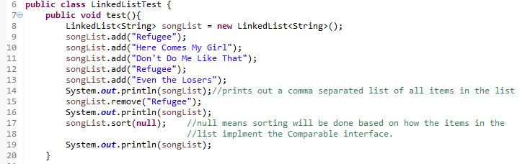
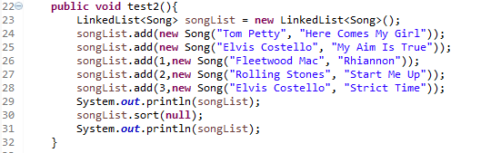
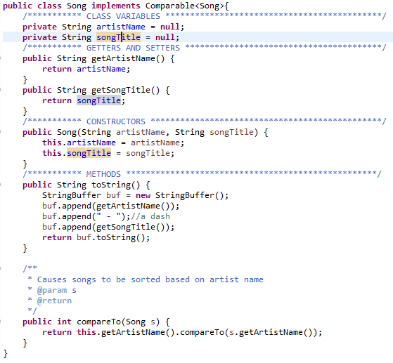
Homework 3b – Working with LinkedLists
Student Name: Andrew Steele
Figure 1
Consider the code snippet shown in Figure 1 and answer the following questions:
- (2 points) What will be printed out in line 14?
[Refugee, Here Comes My Girl, Don't Do Me Like That, Refugee, Even the Losers]
- (2 points) What will be printed out in line 16?
[Here Comes My Girl, Don't Do Me Like That, Refugee, Even the Losers]
- (2 points) What will be printed out in line 19?
[Don't Do Me Like That, Even the Losers, Here Comes My Girl, Refugee]
Figure 2
Figure 3
Consider the Student class shown in Figure 3 and the code shown in Figure 2 and answer the following questions:
- (2 points) What will be printed out in line 29?
[Tom Petty - Here Comes My Girl, Fleetwood Mac - Rhiannon, Rolling Stones - Start Me Up, Elvis Costello - Strict Time, Elvis Costello - My Aim is True]
- (2 points) What will be printed out in line 31?
[Elvis Costello - Strict Time, Elvis Costello - My Aim is True, Fleetwood Mac - Rhiannon, Rolling Stones - Start Me Up, Tom Petty - Here Comes My Girl]

BONUS QUESTION (2 points)

- Update the Song class so that, when a list of Songs is sorted, it is first sorted by artist name and then by song title. That is, if there are multiple songs by the same artist in the list, then, for that artist, the items should be sorted by song title. For the songs shown in Figure 2, for example, the output would look like this:
[Elvis Costello - My Aim Is True, Elvis Costello - Strict Time, Fleetwood Mac - Rhiannon, Rolling Stones - Start Me Up, Tom Petty - Here Comes My Girl]
Copy-and-paste your entire updated Song class here. Include a main method in the class that will test the Sort functionality described. Make sure there are multiple songs by the same artist in your test list of songs.

